Task 1

<!DOCTYPE html>

<html lang="en">

<head>

<meta charset="UTF-8">

<meta name="viewport" content="width=device-width, initial-scale=1.0">

<title>order list</title>

</head>

<body>

<ul>

<li>Movies</li>

<ul>

<li>pushpa</li>

<ol>

<li>Daakko Daakko Meka</li>

<li>Srivalli</li>

<li>Oo Antava Oo Oo Antava</li>

<li>Saami Saami</li>

<li>Eyy Bidda Idhi Naa Adda</li>

</ol>

</ul>

<ul>

<li>Kalki</li>

</ul>

<ol>

<li>Song 1</li>

<li>Song 2</li>

<li>Song 3</li>

</ol>

</ul>

</body>

</html>

Output

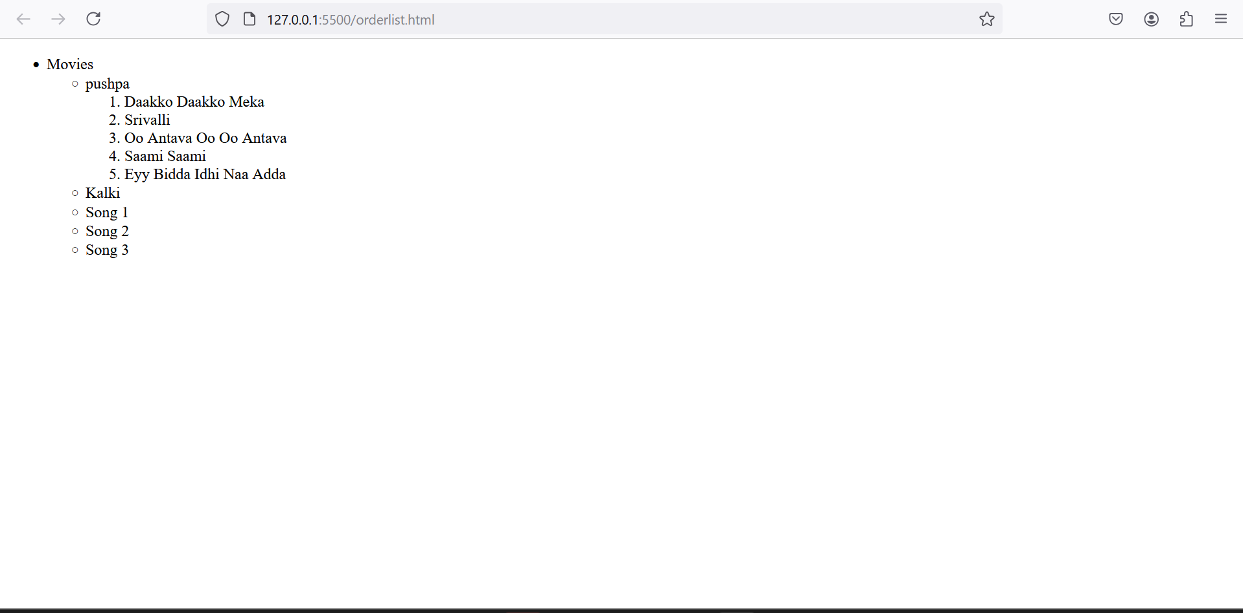

Task 2

<!DOCTYPE html>

<html lang="en">

<head>

<meta charset="UTF-8">

<meta name="viewport" content="width=device-width, initial-scale=1.0">

<title>details and summary</title>

</head>

<body>

<details>

<summary>Front end</summary>

<details>

<summary>html</summary>

<a href="https://en.wikipedia.org/wiki/HTML" target="_blank"> <img src="/photos/html pic.png" width="100" alt=""></a>

</details>

<details>

<summary>css</summary>

<a href="https://en.wikipedia.org/wiki/CSS" target="_blank"> <img src="/photos/css.png" width="100" alt=""></a>

</details>

<details>

<summary>Javascript</summary>

<a href="https://en.wikipedia.org/wiki/JavaScript" target="_blank"> <img src="/photos/images.png" width="100" alt=""></a>

</details>

</details>

<br>

<details>

<summary>Backend</summary>

<details>

<summary>Python</summary>

<a href="https://en.wikipedia.org/wiki/Python_(programming_language)" target="_blank"> <img src="/photos/python.jpeg" width="100" alt=""></a>

</details>

<details>

<summary>Java</summary>

<a href="https://en.wikipedia.org/wiki/Java_(programming_language)" target="_blank"> <img src="/photos/java.png" width="100" alt=""></a>

</details>

<details>

<summary>.net</summary>

<a href="https://en.wikipedia.org/wiki/.NET_Framework" target="_blank"> <img src="photos/net.png" width="100" alt=""></a>

</details>

</details>

</body>

</html>

Output

